**FOOTBALL STRATEGY ANALYSIS**

* **by Anshika Singh**

Dashboard **–**

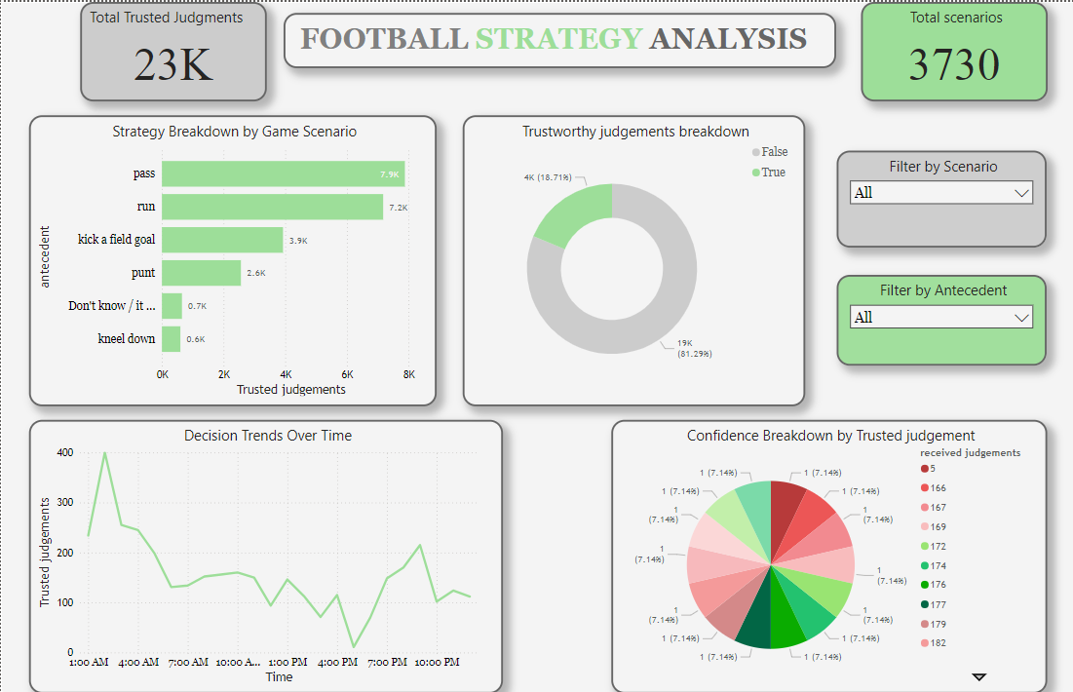

Overview –

The dashboard provides a comprehensive view of football strategies, leveraging data-driven insights. The primary goal of the analysis is to track trusted judgments, strategy breakdown, and decision-making trends over time. The dataset contains over 23,000 trusted judgments derived from 3,730 unique scenarios, which are visualized to assist in understanding strategic choices in various game situations.

Key Visualizations and Insights -

1. Total Trusted Judgments - 23,000 trusted judgments.
2. Total Scenarios - 3,730 unique scenarios.
3. Strategy Breakdown by Game Scenario

- Top Strategies Identified:

Pass– 7,900 judgments

Run– 7,200 judgments

Kick a Field Goal– 3,900 judgments

Punt– 2,600 judgments

Kneel Down– 600 judgments

- Insight: The most common strategic choices are passing and running, which are typically considered more aggressive plays aimed at advancing the ball. The lower frequency of decisions like punting or kneeling down indicates these are used in more specific or situational contexts. The relatively high count for "kick a field goal" suggests frequent scenarios where teams opted to take points over aggressive plays.

4. Trustworthy Judgments Breakdown

- True Judgments:19,000 (81.29%)

- False Judgments:4,000 (18.71%)

5. Confidence Breakdown by Trusted Judgment

Pie Chart Breakdown: The chart shows a color-coded breakdown of the confidence level associated with each trusted judgment, using a 5-point scale (1-5). Each level holds an equal 7.14% distribution.

- Insight: The uniform distribution suggests that confidence levels are evenly spread across the judgments. This could imply a balance in the types of decisions being made, with no overwhelming dominance of overconfidence or uncertainty.

Conclusions -

The Football Strategy Analysis dashboard provides a valuable tool for visualizing and understanding the strategic decision-making process in football. Key insights include:

- The predominance of passing and running as the preferred strategies.

- High trust in the majority of decisions (over 81% marked as true).

- Clear trends in decision-making times, possibly reflecting football workflows.

- Balanced confidence levels, suggesting thoughtful consideration in each judgment.